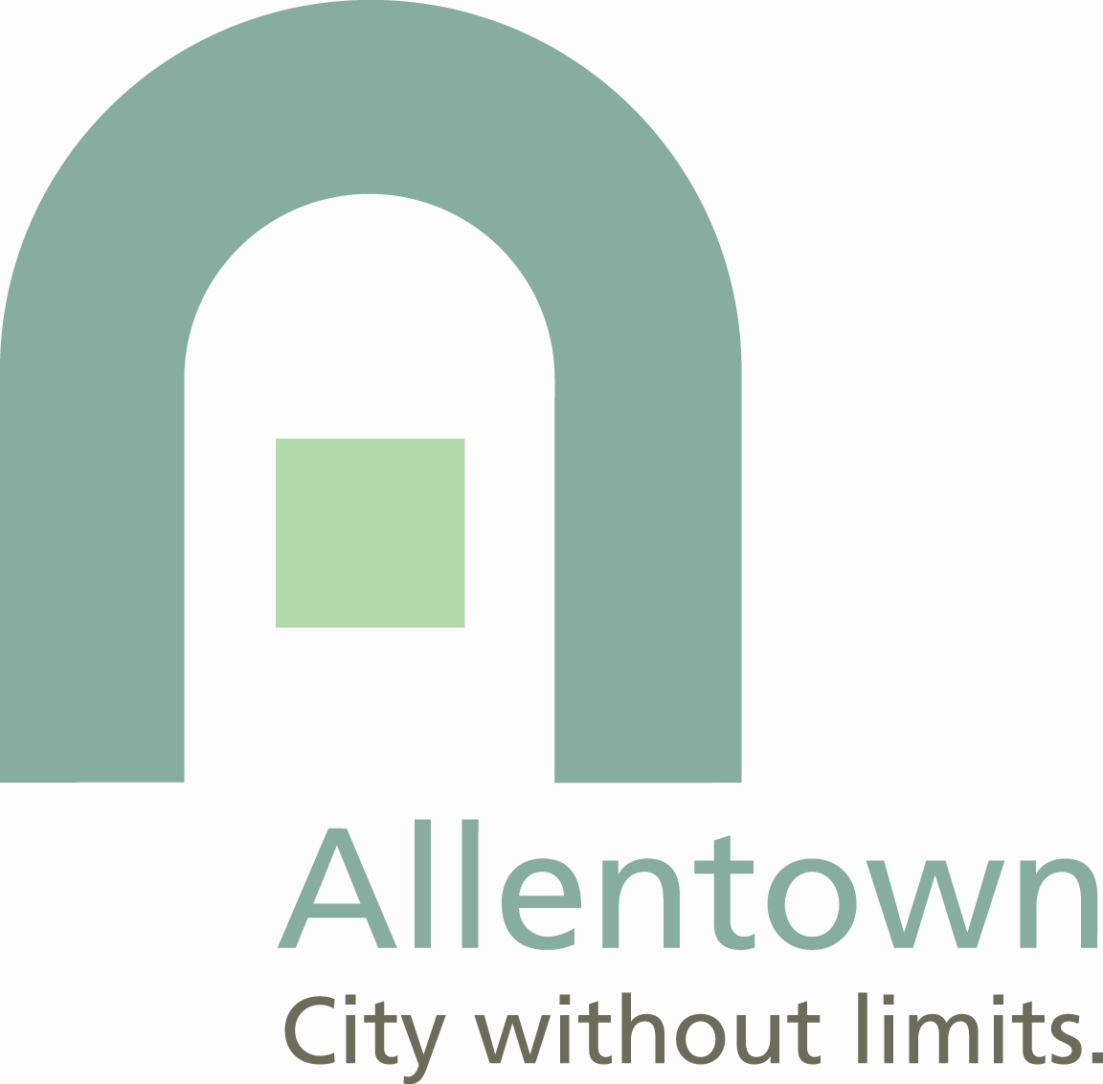
Mike Moore

Communications Coordinator
Office of the Mayor
610 437-7653 office
610 437-8730 fax
moorem@allentowncity.org

NEWS RELEASE

May 19, 2011

For Additional Information Please Contact:

Mike Moore

Communications Coordinator
610-437-7653

ALLENTOWN PUBLIC WORKS SAVING ENERGY

The City of Allentown Department of Public Works is putting its share of a $1 million stimulus program grant to work on reducing energy consumption and improving energy efficiency. Mayor Ed Pawlowski highlighted three of the programs today during a news conference at City Hall to observe National Public Works Week. Representatives of PPL, S&S Energy Technologies, All-Star Fleet Services, Advanced Enviro Systems, and Waste Management were on hand to join in the observance and answer questions about their products.

The funding comes from the Energy Efficiency and Conservation Block Grant (EECBG). The EECBG program was funded under the American Recovery and Reinvestment Act of 2009. It is intended to assist cities, counties and states to develop and manage energy efficiency and conservation projects which will 1) reduce fossil fuel emissions, 2) reduce the total energy use of the municipality, 3) improve energy efficiency in transportation, building and other sectors and 4) create and retain jobs.

The city is currently replacing all lighting control devices in City Hall and Public Safety buildings with vacancy sensing sensors and energy efficient fixtures. The project is saving electricity and reducing carbon emissions. All areas of buildings will be controlled by vacancy sensing light switches that will illuminate only occupied areas of the buildings. Areas such as the parking garage will be illuminated in zones as needed with only security lighting to be used 24 hours a day.

Lighting typically accounts for 35-40% of the electrical energy consummed in a building. By reducing the lighting to a truly as needed usage, the city will reduce consumption in some areas by up to 90%. Lights currently on for 168 hours per week are being reduced to 10-15 hours per week. Overall, the city expects to reduce electrical demand for lighting of City Hall and the Public Safety Building by a conservative estimate of 40%. A second phase of the lighting project will include new lightbulbs with dimming ballasts and photocells to allow for daylight harvesting.

“PPL Electric Utilities is proud to have partnered with the City of Allentown on another project to save energy -- this one managing energy use by replacing the lighting control devices in City Hall and Public Safety buildings. With this project, the city continues to set an example for municipalities of finding ways to cut costs and help the environment by becoming more energy-efficient." said Ray Murphy, PPL Electric Utilities Manager for Major Accounts.

Because the city owns and operates a large fleet of vehicles, the city seeks to reduce diesel and unleaded fuel consumption. Declining overall fuel usage will also reduce CO2 emissions. The city installed fuel catalysts on approximately 185 diesel trucks and larger equipment and 135 unleaded fuel vehicles with a mix of pickups, cars and smaller pieces of equipment.

Prior testing was completed on two units that consume a large amount of fuel. S&S Energy Technologies provided the catalysts to the city for evaluation prior to any purchase and all testing was done by both the operator and computerized monitoring.

The city is realizing average fuel savings of 9% on its nine street sweepers. Those units consumed more than 13,000 gallons of fuel in 2008. Fuel usage dropped to 11,900 gallons in 2009 and 11,700 gallons in 2010. The city’s over-the-road tractor fleet is seeing an average 13% increase in fuel efficiency.

“S&S Energy Technologies is pleased to be able to help the City of Allentown save on fuel costs as well as reducing exhaust emissions on their fleet of vehicles and equipment,” said Vice President Steve Shedroff. “We would like to thank Mayor Pawlowski as well as Craig Messinger and his team. Without their dedication to helping the city reduce costs, this project would not have come to fruition.”

The city collects litter from hundreds of sidewalk receptacles around the city in commercial and residential areas separate from regular trash collection. Some of the receptacles are emptied up to six days per week, which is costly on fuel consumption and carbon emissions.

Through the EECBG grant the city will be installing 15 Big Belly solar trash compactors and 8 public space recycling units.

The Big Bellies are made from recycled materials. They have sensors inside each unit to detect the trash levels and it uses a solar powered motor to compact the trash. This increases the capacity of the litter receptacle by five times and will reduce operational costs by up to 80%. It can compress 180 gallons of waste into a 35 gallon trash bag.

With the Big Belly recycling units for cans and bottles, Allentown launches its first public space sidewalk recycling initiative. These cans and bottles that were previously landfilled will now be recycled and will help to promote a green community in Allentown.

Lastly, the Big Belly has wireless technology capabilities that will monitor the trash levels of each unit. It will allow the Bureau of Recycling and Solid Waste to see real time operations data on the computer to allow for maximum efficiencies for route and collection planning. In addition to lower costs associated with trucks and fuel, Big Belly will also reduce green house gases and other harmful emissions by 80%.

“These improvements are providing real savings for the city,” said Pawlowski. “It is especially important during this time of high fuel prices. We’re also reducing our carbon emissions which results in cleaner air for all of us.”

The stimulus grant funds are paying for all three projects. The Fitch Fuel Catalysts cost $150,000 with final installation costs estimated at $7,500. The cost of the lighting project is estimated at $128,000 and the solar trash compactors come in at $79,000.

About $750,000 is going toward specific city-infrastructure projects. The remainder will fund the Allentown Energy Conservation Program. This program has a loan-interest-rate buy down facet and a rebate facet, both aimed at encouraging residents, commercial property owners, and non-profit organizations in the city to make energy-saving improvements to their properties. More information is available on the city website at www.allentownpa.gov. Click on the Go Green box!

Mayor Pawlowski issued a proclamation designating May 15-21 as National Public Works Week in the City of Allentown. The City Public Works Department has set-up a display with information on various projects and programs on the first floor of City Hall near City Council Chambers.
--30--

